The arrival of the railway in 1883 saw Blackwood change from a small, rural settlement to a highly desirable outer suburb where residents could enjoy the invigorating fresh Hills air, while commuting daily to the city. More houses and shops were built for the expanding population.
During this time corner stores, sometimes referred to as general stores, played an important role. These small shops sold a wide range of goods to the community – almost everything needed for day-to-day living. The three identified for this tour – 1923, Bracegirdles and Sheoak Café – were indeed ‘corner stores’. Similar stores existed in Eden, Belair and Coromandel Valley. Limited transport options meant that the stores were often within walking distance of nearby dwellings. Some of them were family businesses with their home adjoining the shop. Women who otherwise were often isolated at home welcomed a visit to the corner store where they could exchange news and share information. Of major importance was that owners knew their customers and welcomed the regulars.
What did such shops sell? Residents recall the interesting smells on entering a grocer’s shop, a mixture of spice, coffee and tea, biscuits, and sugar. The bins at the back of the counter had hinged lids, and it was possible to buy a paper bag of broken biscuits. Biscuits were stored in square silver tins and weighed out into paper bags. It was the same for flour and sugar. There was always a wooden chair for weary customers to take the weight off their feet, and a jar of boiled sweets on the counter, to be distributed gratis to young customers. (Callen 2003) The corner store often housed the local post office, and in later times sold newspapers and had the only petrol bowser in the community.
Some features of the corner store were found in grocery stores, several of which existed in Blackwood and nearby following World War II. They disappeared with the arrival of the supermarkets in the 1960s.
The role of the corner store in early communities was greater than the building or its contents. They provided a social hub for communities separated by distance from the sophisticated life of the capital city with its specialist shops.
It is this role of social hub which has been taken over by the numerous coffee shops and cafes which abound in Blackwood and the surrounding district. No longer separated by distance from the city, many residents choose to visit local establishments for their tea, coffee and cake shot, sometimes daily. And importantly, to be recognised by the staff who remember their preferences.
While the concept of the corner store has disappeared, a number of the buildings in the Blackwood district still exist. That we are now able to get our daily coffee shot in these charming old buildings is a bonus.
Café 1923
Address: 28A Coromandel Parade Blackwood 5051
Phone: 8278 9889
Opening hours: Closed Monday, Tuesday-Friday 7.30am–2.30pm, Saturday-Sunday 8am-2.30pm

In 1923 William John Dunstan who had previously operated stores in Belair and further south on Coromandel Parade, built a shop/house, now Café 1923, at 28 Coromandel Parade on the corner of Brigalow Avenue. He operated this corner store until after WWII.
During the late 1940s to early 50s the shop was rented by Miss Joy Thorpe who ran it as a drapery and haberdashery shop. Ribbons and laces were spread daintily on the counter and stored in many shoe boxes. There was an underlying smell of moth balls.
In the 1950s, it was a branch of Axfords Home Service Stores selling groceries.
The purchase in the early 1960s by August (Gus) Zessack saw the beginning of a new era as an eating place for a shop which had been a grocery store for much of the century. Zessack, a German pastry cook who had worked at Café de la Paix in Paris operated his café here with the same name for many years.
The shop had been closed for a number of years until it was purchased in 2010 by Patty Bakewell who renovated the abandoned building and brought Café de la Paix back to life.
In 2015 the business was sold and became 1923.
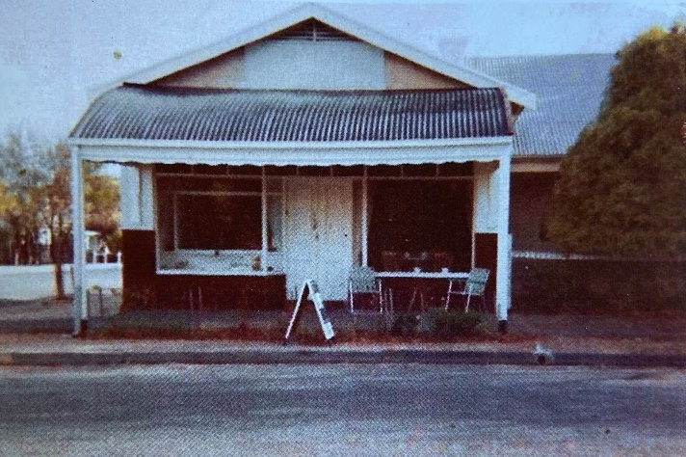
Source: P. Bakewell, late 1960s
Bracegirdles
Address: 386 Shepherds Hill Road Blackwood 5051
Phone Number: 8423 0871
Opening hours: Monday-Saturday 7am-5pm, Sunday 8am-5pm
In the 1880s Fred Mason had the first butcher shop built in Blackwood on what is now the south west corner of the roundabout. Initially the animals were bought in Adelaide and driven to Blackwood via Goodwood Road, Princes Road and Old Belair Road with sheep being slaughtered at the back of the shop. Early shoppers were not shielded from the source of their meat like modern shoppers. Headless animal carcasses, strings of sausages and joints of meat hung in butchers’ shops, with pictures of the animals in life on the counter in case shoppers needed reminding.
In 1915 Mason sold the Blackwood Butchery to George Brook who in turn sold it to WA Jones in 1919. The Jones family ran the business until the mid 1950s meaning that the butcher trade of the district was in the one family for 90 years. There being no refrigeration, all killing had to be done either late at night or early in the morning in summer months. Jones Butchers kept horses on the site where Woolworths now stands with meat deliveries being by horse drawn cart six days a week.
The Fairley family came to Australia in 1927 and settled in Blackwood. Initially Joe Fairley rode his bicycle around the district repairing shoes until he opened his first shop in Station Road. The shop later moved to Jones Corner where it stayed until 1970, at which time Heynes electrical and later Blackwood Sound took over the space. Following extensive renovations by former local teacher Garry Bracegirdle and his chocolatier wife Sue, the building once again became a home for food and chat.
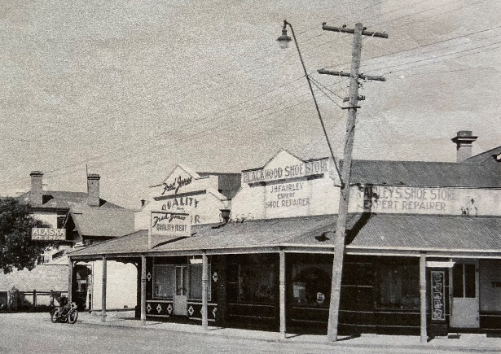
Source: Mitcham Heritage Research Centre
Sheoak Cafe
Address: 38 Sheoak Road, Belair 5052
Phone: 0412 983 151
Opening hours: Daily 8am – 4pm

In 1848 Mr Koll built a house near the top of Old Belair Road that was used as a store and in the early 1850s Gustav Ludewigs built a house, one room of which was used as a store and post office near the Belair Triangle. There was also a village store at 43 Sheoak Road. This may have been built by local resident Dr Hamilton for his gardener, with one room used as a shop
Well-known Blackwood shopkeeper, W J Dunstan, built the present shop in 1914, soon after the opening of the railway bridge connecting Sheoak Road with Upper Sturt Road. Mr Dunstan sold groceries and other goods and later added a postal service. James Halstead and his son Roth owned the store from 1926 – 1960, adding a petrol bowser in the 1920s. It was a typical country store with groceries, a banking service and pigeonholes for letters.
Later owners were the Bradbrooks who sold the business to the Shircores in 1986. In addition to many renovations which included moving the stairs to the basement where they sold vintage and antique items, they created a cafe and replaced the now missing old petrol pump with a newer pump sourced from Apsley near Eden Hope in Victoria. This was positioned on a plinth in the same location as the original.

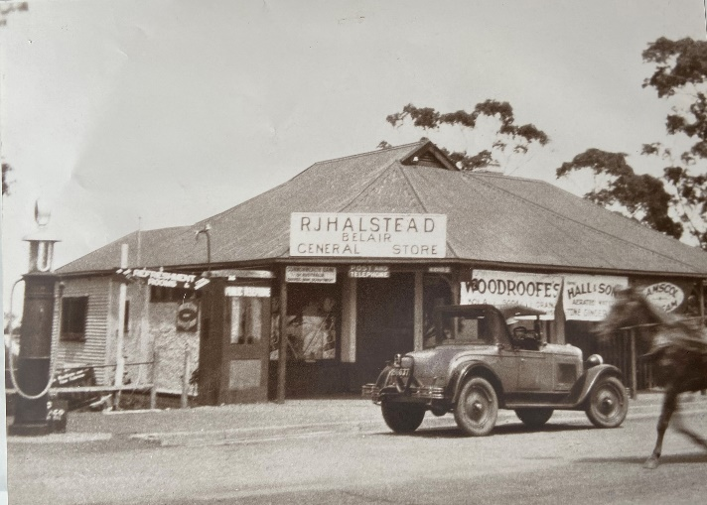



Source: A. and B. Shircore

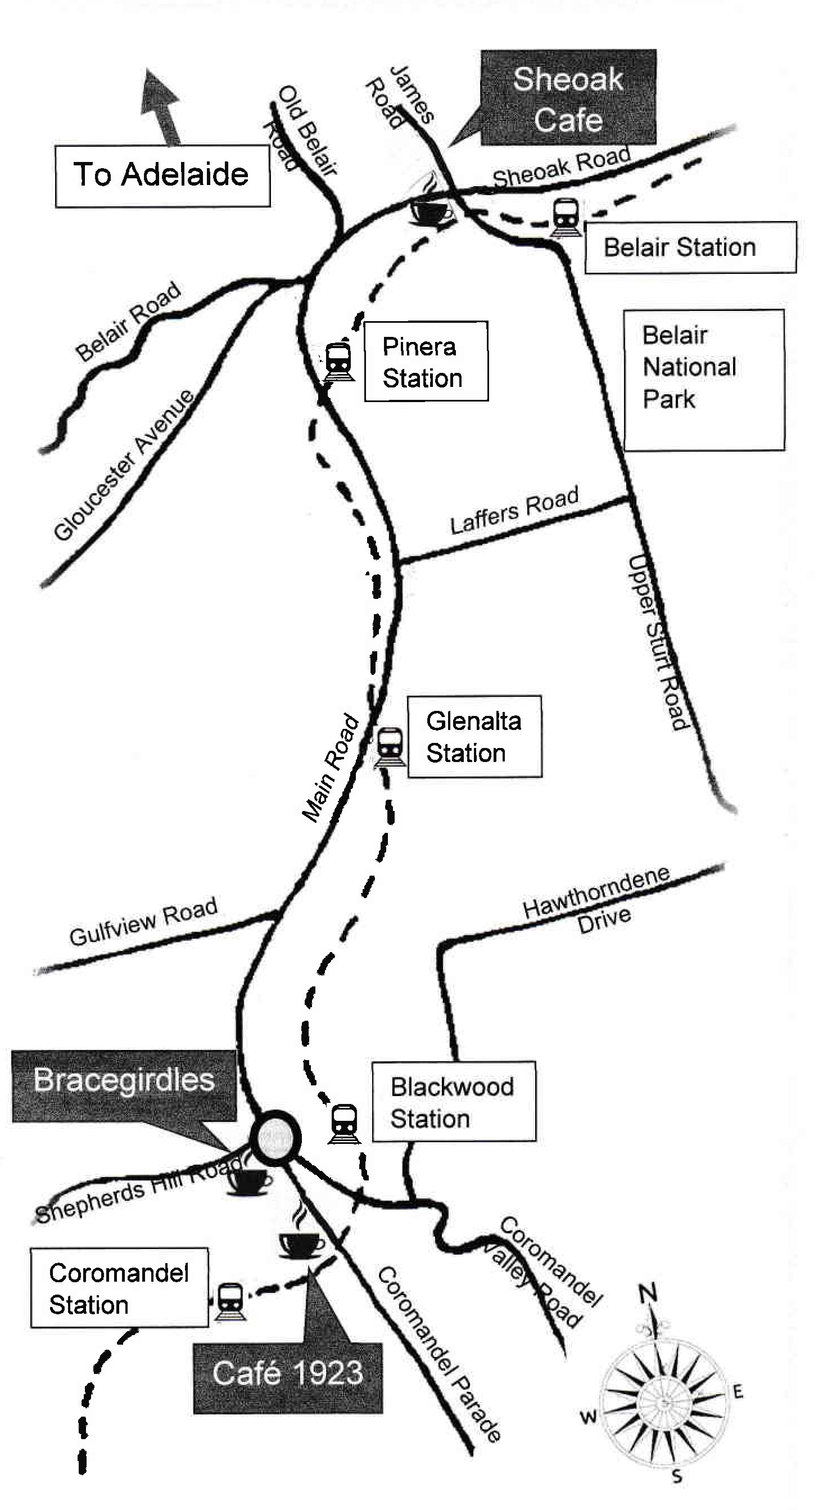

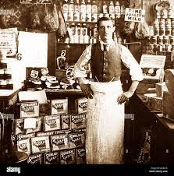
Blackwood Action Group
South Australia’s History Festival

FROM CORNER STORE
to CAFÉ
May 2022
Self-Guided Tour

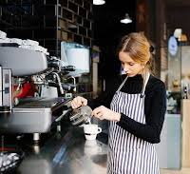

Visit these “Corner Stores”
to see more memories from the past

